**MIDDLETON CHENEY FOOTBALL CLUB**

**ANNUAL GENERAL MEETING**

**1970**

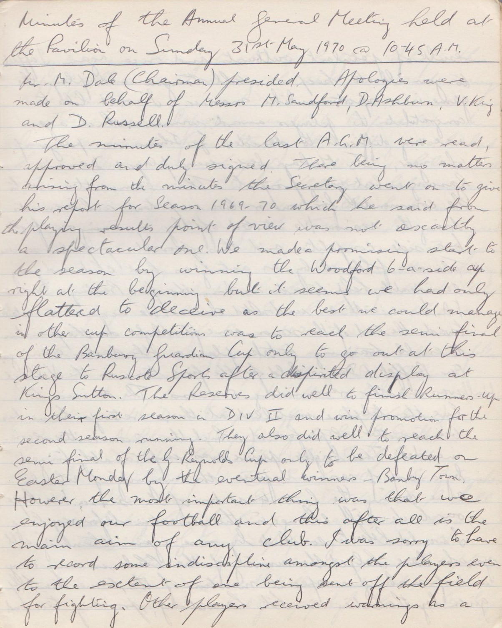

**Continued**

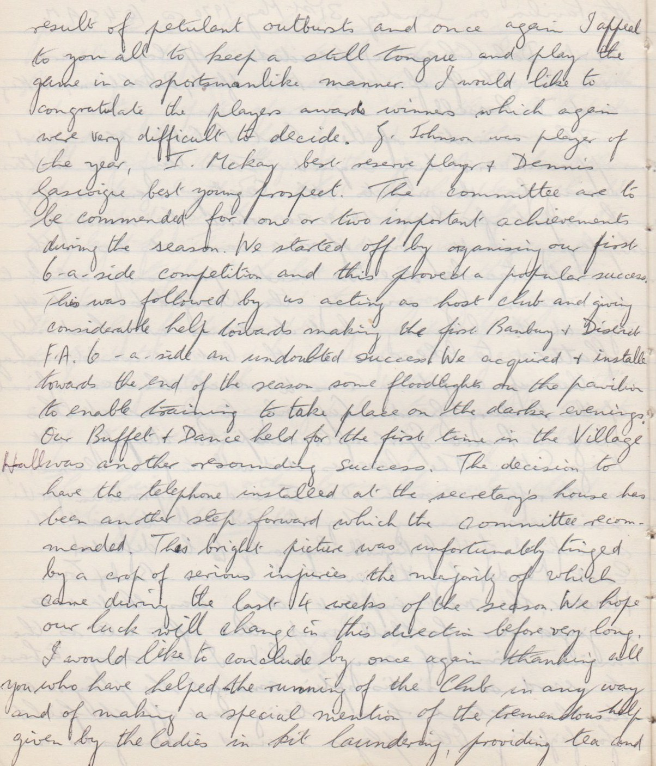

**Continued**

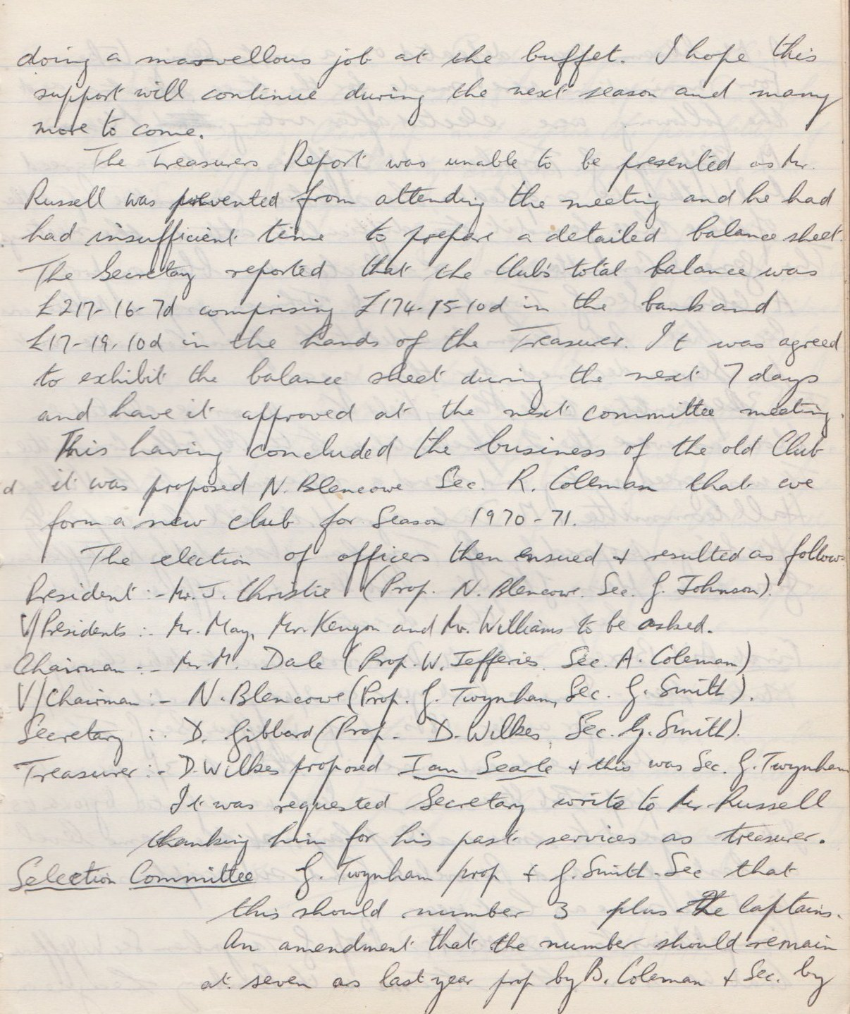

**Continued**

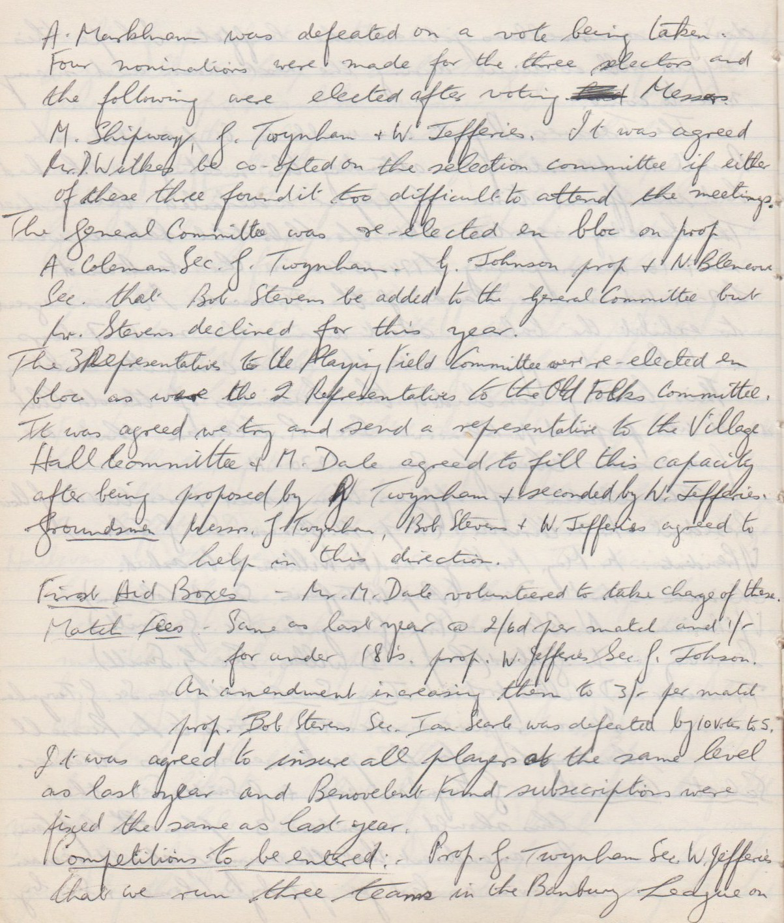

**Continued**

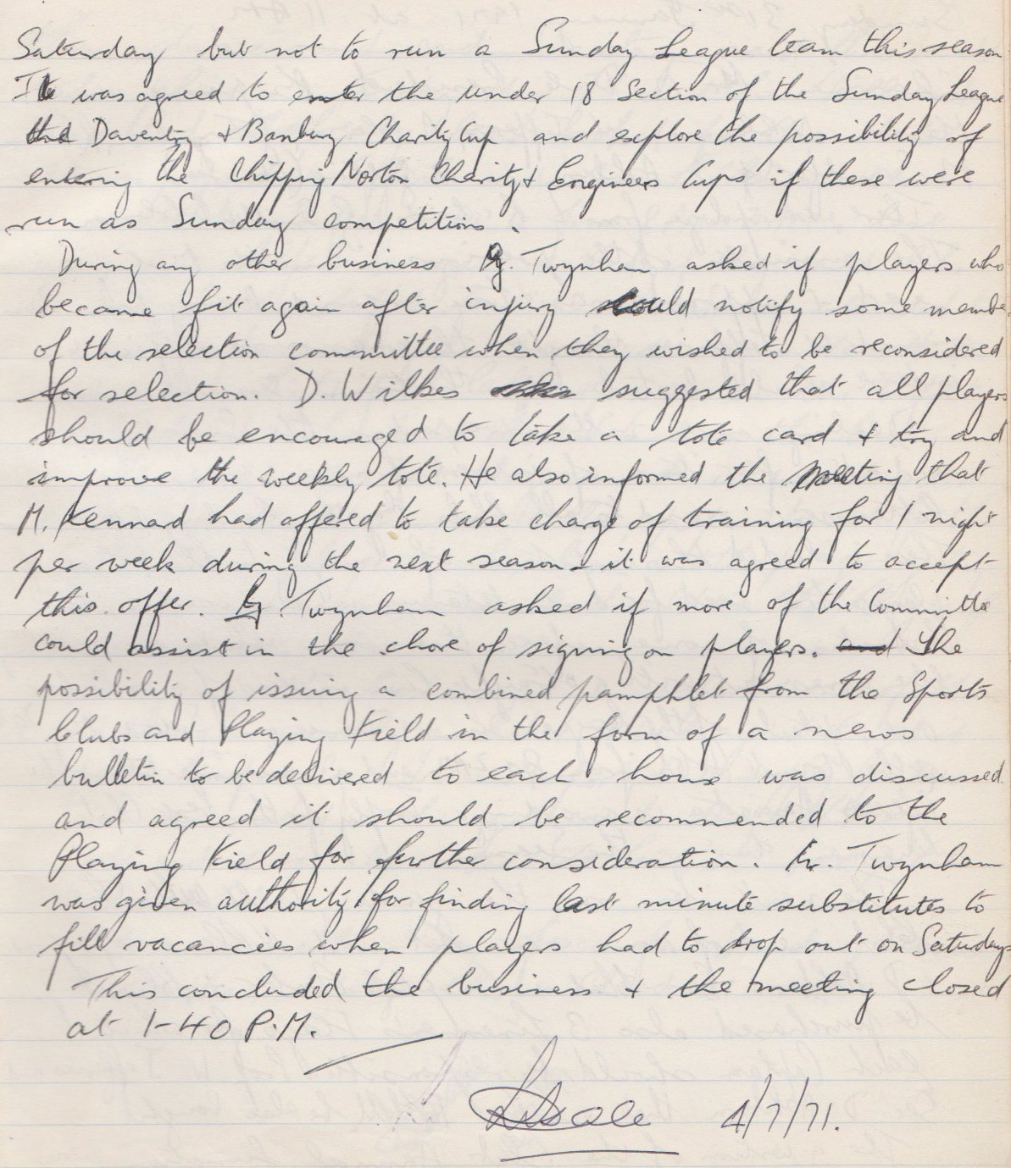

**General Committee Meeting**

**January 31st 1971**

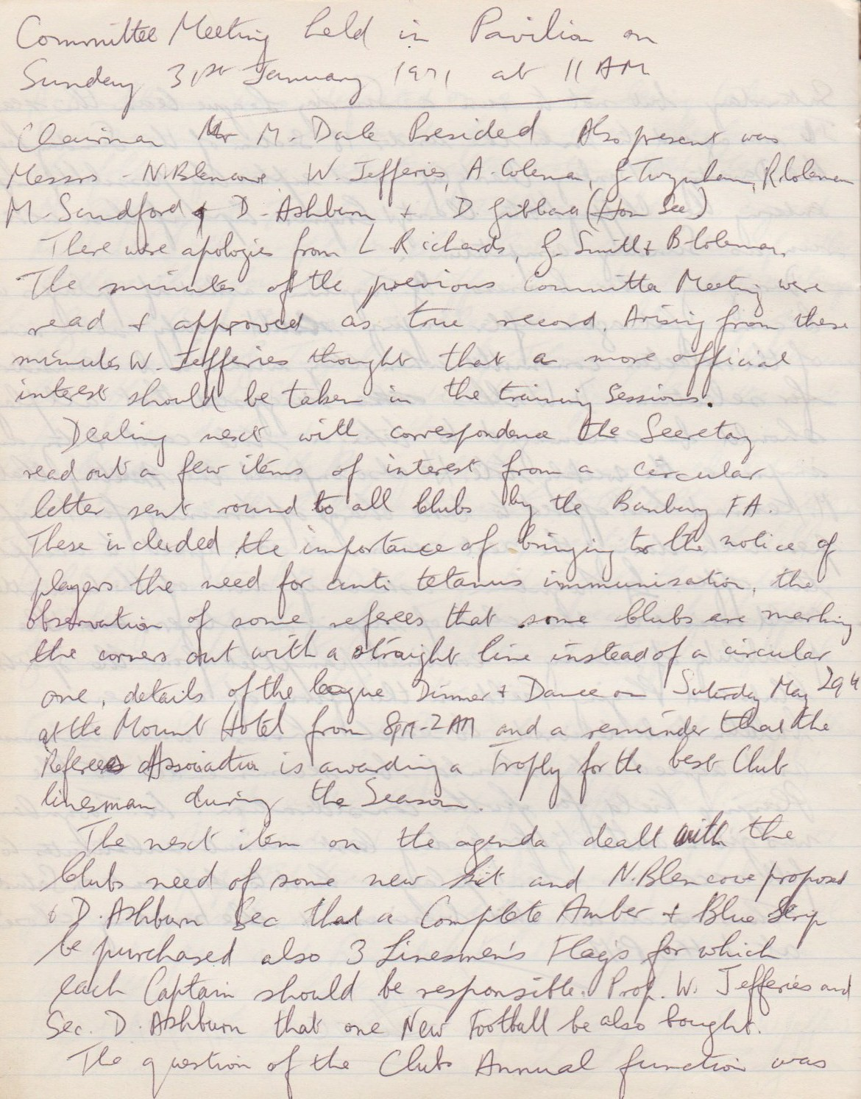

**Continued**

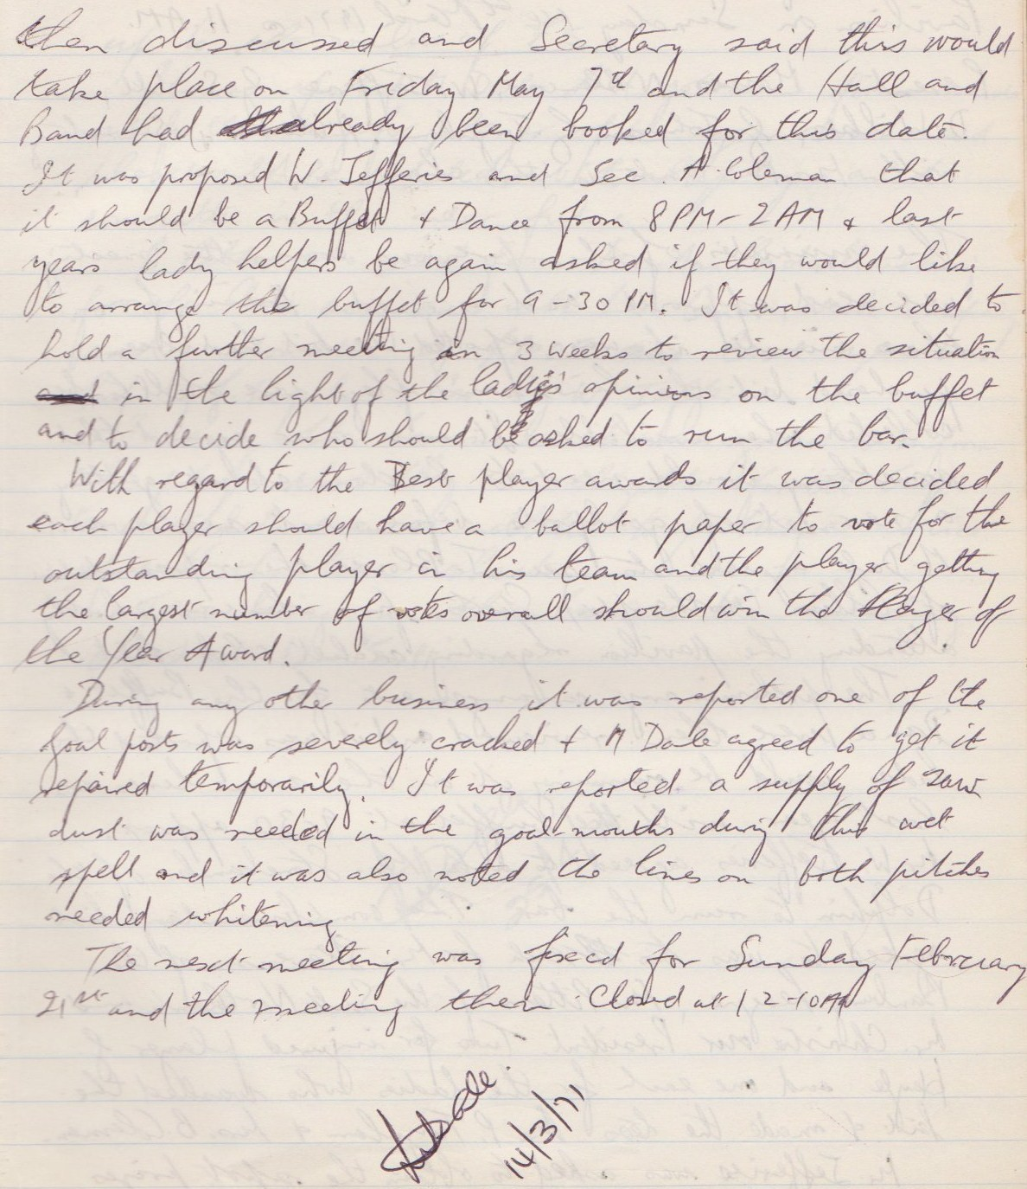

**General Committee Meeting**

**March 14th 1971**

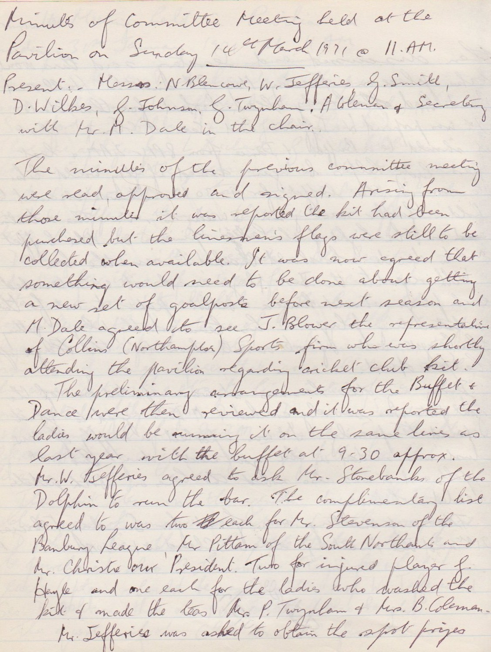

**Continued**

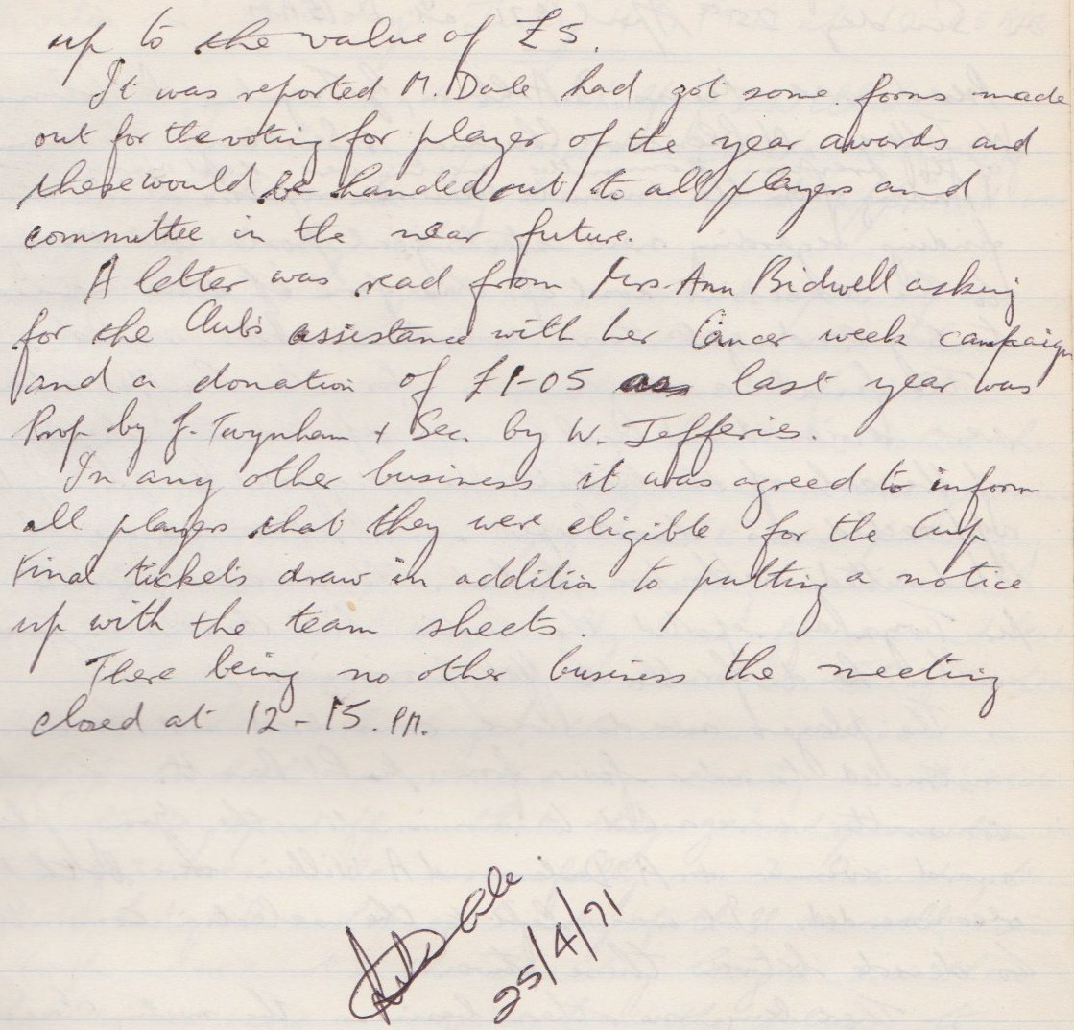

**General Committee Meeting**

**April 25th 1971**

